Universal input gain control confers robust combinatorial odor coding in naturalistic environments

Nirag Kadakia1,2 and Thierry Emonet2,3

1 Swartz Fellow of Theoretical Neuroscience

2 Department of Molecular, Cellular, and Developmental Biology, Yale University, New Haven, CT 06511, USA

3 Department of Physics, Yale University, New Haven, CT 06511, USA

September 10, 2018

Animals identify and discriminate odors using ol- factory receptors (Ors) expressed in olfactory recep- tor neurons (ORNs) [1, 2]. In both insects and ver- tebrates, distinct ORNs, which typically express a single Or, respond broadly to many distinct volatile odorants [3, 4, 5, 6, 7, 8]. Likewise, any given odor- ant may incite strong responses in a number of ORNs. ORN tuning curves are therefore broad and overlap- ping, implying that odors are encoded combinato- rially – by the particular combination of responses they elicit in the ORN repertoire, patterns which are eventually decoded downstream into behavioral re- sponse [9].

Odor signals in nature are uniquely complex in composition, space, and time, and like other sen- sory modalities, olfactory systems must tune their response to the character of input stimuli [10, 11, 12, 13, 14]. Various features of natural odor sig- nals are power-law distributed, producing whiffs of widely varying duration and intensity [12]. Sensitiv- ity to low concentrations could thus lead to saturation at high intensities, confounding combinatorial repre- sentations of odor identity. Further, ethologically- relevant odors are often mixed together with nuisance odors; due to the non-specificity of ORN response, distinct odors could simultaneously activate overlap- ping ORN subsets, preventing accurate disambigua- tion [15].

What invariances and adaptive mechanisms might help preserve combinatorial odor representations in natural environments? In *Drosophila* larvae, dose re- sponses of 324 OR-odorant combinations obey a sin- gle activation function shape, with similar Hill coef- ficients but different activation thresholds, which are distributed as a power law [16]. *Drosophila* ORNs also exhibit a large degree of similarity in their tem- poral integration of fluctuating stimuli. While for some Or-odor combinations, ORN response can ex- hibit large differences, such as super-sustained re- sponses [17], deconvolution of stimulus dynamics from neuron responses produces stereotyped filters that differ little among ORNs [18].

Beyond these invariances are adaptive mechanisms which can preserve odor representations amid en- vironmental changes. In *Drosophila*, antennal lobe glomeruli receiving connections from ORNs send mu- tually inhibitory connections, effectively normalizing incoming ORN signals before they are projected to the lateral horn and mushroom body [19, 20]. In the mushroom body, inhibition from giant interneuron upon Kenyon cells further acts to suppress patterns

of activity elicited by these odors [21]. Further, up- stream of these connectivity-mediated mechanisms, individual ORNs themselves adapt in time an appar- ently universal way: ORN gain varies inversely with mean odor concentration according to Weber’s Law of psychophysics [22], while maintaining response time independent of odor intensity [14, 23, 24]. Weber’s Law has been observed in several OR-odorant com- binations, and is traced to feedback mechanisms op- erating at the level of odor transduction, upstream of ORN firing machinery [14]. This points to a mech- anistic origin involving modification of phosphorly- ation sites on the universal *Drosophila* co-receptor Orco. Other phosphorylation sites on Orco have been implicated in desensitization to odors over longer timescales as well [25, 26].

While in a single channel system such as *E. coli*, adaptive feedback via Weber’s Law is known to ro- bustly maintain sensitivity in response to mean con- centration changes, the implications for a multiple- channel system – which combines information from several sensors with overlapping receptive fields – is less straightforward. Here we combine a biophysical model of universal ORN adaptive response and neural firing with various sparse signal decoding frameworks to explore whether and how ORN adaptation main- tains accurate combinatorial coding of odor signals that span varying degrees of intensity, molecular com- plexity, and temporal structure. We find that front- end gain modulation helps preserve coding capacity within the non-specifically sensing ORN repertoire, and maintains abstract representations of odor iden- tity across different intensities. As such, this adaptive mechanism promotes the accurate discrimination of weak odor signals from strong backgrounds of vary- ing molecular complexity, both in static odor environ- ments and in fluctuating ones. We also investigate the predictions of our model for the *primacy coding* hy- pothesis – that odors are encoded entirely by the sub- set of a few earliest responding ORNs [27, 28]. Our re- sults agree with primacy coding when odor signals are sufficiently simple, though signals composed of more molecular constituents require the recruitment of the full ORN repertoire. Finally, we show that front-end adaptation acts in concert with divisive normaliza- tion in the antennal lobe to maintain the invariance of activity patterns in the mushroom body. Together, our results suggest that despite the broad overlap of ORN tuning curves, a universal mechanism of front- end adaptation may play a vital role in preserving representations of odor identity in naturalistic odor

landscapes.

# Results

to-ORN transformation with a temporal filter fol- lowed by rectifying nonlinearity *f* (see Methods):

## a Model of ORN sensing repertoire

Odor identification consists of encoding in the sensing periphery followed by decoding in higher-level pro- cessing centers of the olfactory circuit. We first exam- ine how front-end adaptation can maintain odor en- coding capacity, by drawing upon a model of odor-to- ORN firing recently shown to reproduce experimen- tal findings: Weber-Fechner scaling, signal transduc- tion kinetics, and firing rate dynamics of individual *Drosophila* ORNs to fluctuating stimuli [14]. Here we generalize this model to a repertoire of *M* = 50 ORN types. ORNs house olfactory receptor com- plexes C*a*, *a* = 1*, ..., M* , each consisting of an ORN- specific OR and the universally-expressed olfactory co-receptor Orco, which mediates odor transduction

*ra*(*t*) = *f* (/ *h*(*τ − t*)*Aa*(*t*)*dτ* \ *.* (2)

At the single ORN level, this nonlinear-linear- nonlinear framework (Or/Orco activation tempo- ral filter nonlinear rectifier) reproduces Weber Law gain adaptation and signal transduction kinetics, no- tably the temporal slowdown of the local field poten- tial upon adaptation, along with a complementary speed-up in the firing machinery.

*→*

*→*

Here *Ea*(*t*) represents the free energy change due to modifications of the Or/Orco complexes by adap- tation. Opening of the channels causes an inward current that eventually results in a negative feedback onto *A*(*t*). This is modeled minimally by:

through dendritic localization of and heteromeriza-

*dEa*(*t*) = *Aa*0 *− Aa*(*t*)

(3)

tion with ORs (Fig. 1a). These odorant-response

functional units interact with odor mixtures, each of which is composed of some combination of *N* odorant molecules with time-dependent concentrations *si*(*t*), *i* = 1*, ..., N* (Fig. 1b). We choose *N* = 150, as this number is sufficiently larger than the size of the sensing repertoire *M* . Functionally, C*a* forms a non- selective cation channel whose current is mediated by the strength and nature of bound ligands. We thus model a given complex as stochastically switching between active (channels open) and inactive states, while also being bound or unbound with odorant *i*. The active conformation binds odorant *i* with higher affinity than the inactive conformation, resulting in distinct dissociation constants, *Ki∗a* and *Kia*, respec- tively. In steady state, the active fraction *Aa* of Or/Orco complexes in ORN *a* can be solved for as (see Methods):

1

*A* (*t*) = (1 + *eE* (*t*)*−*

*a*

*a*

*Ea*(*t*) = *Ea,*act(*t*) + *Ea,*ligand(*t*)

),

*dt τa*

within the finite range *E*L*,a < Ea*(*t*) *< E*H*,a*. It has been shown that when properly deconvolved from the stimulus dynamics, the shape of temporal kernels in adult *Drosophila* ORNs is largely odor-independent, though may differ by brief ( 10 ms) odor-dependent delays [18]. Accordingly, we model *h*(*t*) by an ORN- and odor-independent double-exponential function, with parameters matched to experiment [18]. We assume that the lower cutoffs *E*L*,a* are receptor- dependent and choose them from a normal distri- bution. This variability ensures that ORNs are ac- tivated above quiescence (around 5 Hz) at distinct stimulus levels [14].

*∼*

Diversity among maximal odor-ORN response arises from the distribution of chemical affinities, en- capsulated in *Ka∗i*. We choose these from a power law distribution (*α* = 0*.*35), as was recently found across ORN-odor pairs in *Drosophila* larvae (Fig. 1c). To mimic the presence of private odors relevant to in-

*E* (*t*) = ln

*a,*ligand

1 + *N si*(*t*)*/Kai*

),

*i*

1 +

*N s* (*t*)*/K∗*

*i*

*i*

*ai*

l *,* (1)

nate responses, we manually add a high responder (*Ka∗i ∼* small) to a handful of ORNs; the addition of

these private odors did not affect the general findings.

Together, the power-law distributed *Ka∗i*, receptor-

*i*

*i*

*ai*

Together, the power-law distributed *Ka∗i*, receptor-

where *Ea,*act(*t*) is the free energy cost of C*a* activation.

NAT LOG

Inward currents elicited by activation of the Or/Orco receptor complexes then incite firing activ- ity in ORNs. Following [14], we model the Or/Orco-

dependent *E*L*,a*, and invariance in temporal filters,

when incorporated into the steady-state model re- sponses Eq. 1, produce tuning curves mimicking the maximal *Drosophila* ORN responses to many individ- ual odorants [6] (Fig. 1d-1e).

# A



*t*





**B C**

1 Odorant space *N*

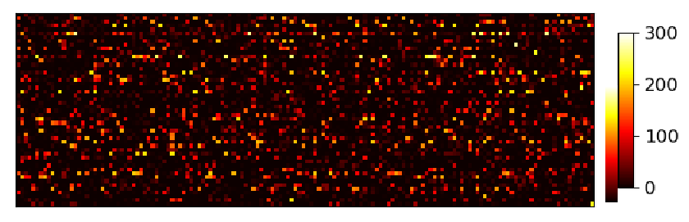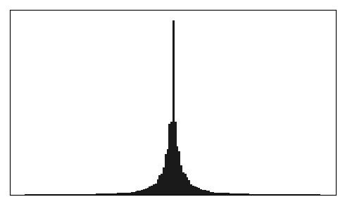

complex odor

mono- molecular odors

**O**1 **O**2

**O**3

# D E

...

**R**1

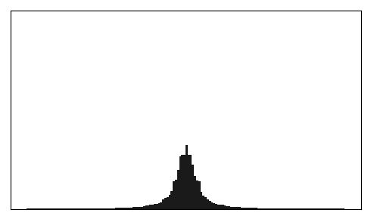

**R**4

**R**8

Firing

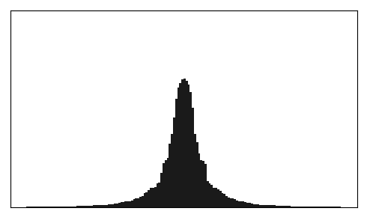

**R**30

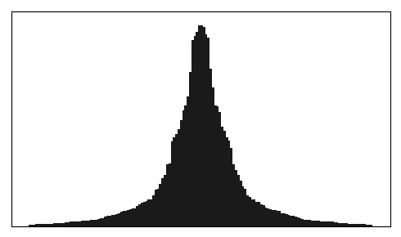

**R**5

Receptor space

**R**N rate

(Hz)

Figure 1: **A** Odor binding model. Or/Orco complexes C*a* bind odorant molecules *si* comprising stimuli S. These complexes can stochastically switch between inactive and active states, where the steady-state active fraction is determined by the complex free energy *.a*(*t*). The activity feeds back on to the free energies with timescale *τa* to pull the activity to a baseline level *Aa*0. ORN firing rates *ra*(*t*) are generated by passing *Aa*(*t*) through a linear temporal filter *h*(*t*) and a nonlinear thresholding function*f* . **B** Odor mixtures are represented by real-valued *N* -dimensional vectors **s**, whose components *si* are the concentrations of the individual molecular constituents of **s**. **C** Following (), active binding constants are distributed as a power-law with coefficient *α* = 0*.*35 **D** The maximal firing response of 50 ORNs to the 150-possible monomolecular odors **s** = *si*, for the power-law *Ka∗i*

distribution in C. **E** Representative ORN tuning curves, generated by ordering the responses within a single row of the response

matrix in D. A diversity of response, mimicking that of [6], arises from both the distribution of odorant binding constants *Ka∗i*

and the distribution of receptor free energies *.a*.

## b Concentration-invariant preservation of coding capacity and abstract

**representations of odor identity**

To investigate the dependence of encoding capacity on odor concentration, we calculate the mutual in- formation (MI) between odor signals **s** and responses **A** in two sensing systems, one with ORN adaptive feedback (via Eq. 3) and one without. We consider a simple situation, in which a step of odor A, **s***A*, turns on at time *t*1, persists for some time, and then odor B, **s***B* (a distinct identity) turns on at some later time *t*2. For simplicity, we assume that both odors have simi-

lar intensities *s*0 = *(si)* and calculate the MI between the ORN responses **r***a* and signals **s***A* + **s***B* at various times after *t*1, as a function of *s*0. In the non-adaptive case, MI peaks around the region of maximum sensi- tivity ( 102 a.u.) after *t*1 (Fig. 2a. ORNs are firing at an elevated rate, however, more susceptible to sat- uration with further odor onsets. Thus, following *t*2, the maximum shifts leftward as odors of high inten- sities have saturated the system and cannot pass any more information.

The adaptive system mimics the non-adaptive sys- tem at *t*1, before adaptation has kicked in (Fig. 2a).

*∼*

4

**A B** odor 1

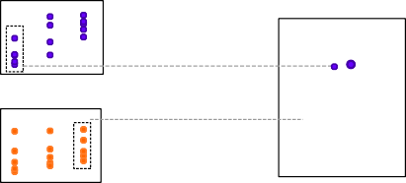

R31

R14

R45

Low-D projection (50 ORNS 2D)

odor 2

odor intensity

ORN firing rates

Odor B

Odor A

Time

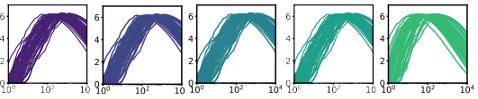Non-adaptive **C**

ts)

bi (

MI

odor intensity

t-sne 1

t-sne 2

10 odors 60 odors

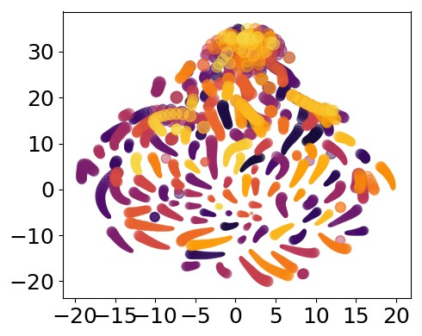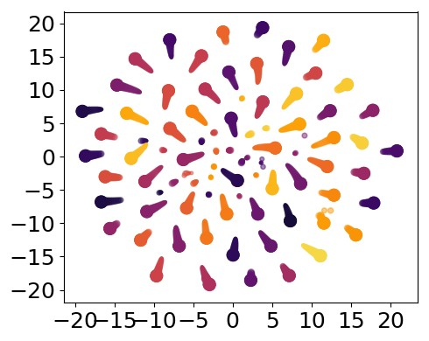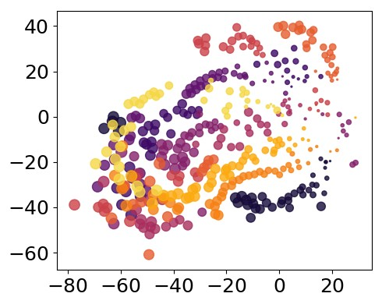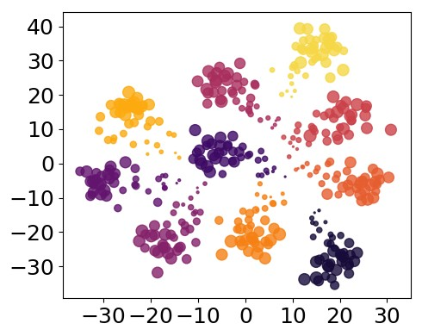

MI (bits)

Non-adaptive

t-sne 1

Mean odor intensity (a.u.)

Adaptive

MI (bits)

Adaptive

t-sne 1

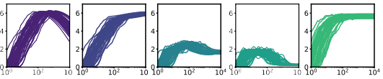

Mean odor intensity (a.u.)

t-sne 2

t-sne 2

Figure 2: Front-end adaptation maintains information capacity and representations of odor identity across changes in intensity. **A** Evolution of mutual information (MI) between odor signals and ORN response, as a function of relative odor concentration. Odor A arrives at *t*1 and Odor B (of similar intensity) arrives at *t*2, where *t*2 *− t*1 *> τA*. MI is plotted for both an unadaptive and adaptive system at times of order of *τA* following *t*1 (purple; purple-blue), right before *t*2 (blue-green), and shortly after *t*2 (green). **B** To investigate abstract representations of odor identity in the ORN response, ORN responses are projected from 50 dimensions to 2 dimensions, using nonlinear dimensionality reduction. In the 2D space, distinct odors are plotted as points of distinct colors, and point size represents odor intensity. **C** In the adaptive system, responses cluster by identity more apparently for an adaptive system (bottom row), than a non-adaptive system (top row), shown here for 10 and 60 sparse odor identities for several concentrations each.

As the activity feeds back onto *Ea*, the response to higher concentrations passes through the regime of high sensitivity, and the MI peak shifts rightward. Over time, the responses for all signals have reached the baseline firing rate, and the mutual information is mostly eliminated since the firing rate is inde- pendent of odor identity. However, having now ad- justed its regime of maximum sensitivity to the pres- ence of odor A, the system can respond appropri- ately to odor B: the MI at *t*2 is nearly 6 bits across 3 decades of concentration, in contrast to the non- adaptive case. These results suggest that in this multi-channel compressive system, a simple mecha- nism of universal integral feedback can help maintain sensitivity in changing environments.

We expect that this preservation of information ca- pacity might therefore help maintain abstract repre- sentations of odor identity. To examine such repre- sentations, we project the ORN response repertoire to

a lower dimensional space using t-distributed stochas- tic neighbor embedding (t-SNE), a nonlinear, local dimensionality reduction technique [29]. Here, each data point is a 50-dimensional vector representing the ORN firing responses to a given odor of a given in- tensity. Each of these data points is then reduced by t-SNE to two dimensions (Fig. 2b). Testing this both for a smaller odor repertoire (10 odor identities) and a larger one (60 identities), we find that odors sepa- rate by identity in the adaptive system, while in the unadaptive system, representations mix among their identity and concentration (Fig. 2b). Together, these results suggest that at the level of ORN response, front-end adaptation helps maintain representations of odor identity across changes in odor intensity.

5

## c Front-end adaptation promotes odor decoding and discrimination accuracy

**amid potential confounds**

Next, we ask how front-end adaptive mechanisms can aid in accurate signal reconstruction from a reper- toire of ORN response. One potentially complicat- ing factor in signal reconstruction is the disparity be- tween measurement dimension and stimulus dimen- sion: while *Drosophila* only express 60 olfactory receptor genes [30], the space of aromatic odorants is far greater [31]. However, many naturally-occurring odors are comprised of only a small subset of these volatile compounds – they are sparse in the space of odorants [31]. This is suggestive as mathemati- cal results in compressed sensing guarantee the re- construction of these sparse signals, assuming a suf- ficiently random response [32, 33, 34]. We empha- size that while at this stage of the analysis we use a compressed sensing framework to decode these sparse signals, there is no evidence that this algorithm is being implemented in the *Drosophila* olfactory cir- cuit [35]. Later, we show that similar conclusions fol- low for odor categorization via binary and multi-class classification.

*∼*

To incorporate the linear framework of compressed sensing into our nonlinear encoding model, we treat the odor encoding process exactly, while approximat- ing the decoding to first order. Specifically, we rep- resent the nonzero components *si* of a sparse odor mixture as *si* = *s*0 + ∆*si*, where *s*0 is the center of the linearization. The target of the decoding process are the ‘excess’ odor signal components ∆*si*, which are determined by enforcing signal sparsity and the measured ORN responses through constrained opti- mization. The cost function to be optimized and the linear constraints are:

ˆ**s** = arg min *|si|* (4)

∆*r* = *f* (/ *h*(*τ − t*) *dAa dτ* \ 111 ∆*s* (5)

*a*

*dsi*

1

*i*

*s*0

sume that number of nonzero odorants comprising the odor, *K*, is small. Note, however, that this still allows for a huge number of distinct odors, e.g. nearly 1 billion for *K* = 7. In the absence of ORN adapta- tion, signals are still correctly inferred in a particular regime of mean odor concentration (Fig. 3b), corre- sponding to that of higher coding capacity in Fig. 2a. Elsewhere, decoding accuracy is low. Conversely, en- forcing Weber-Fechner scaling within the thresholds *E*L*,a* and *E*H*,a*, coding fidelity is maintained over a several-fold change in odor intensity (Fig. 3b).

In natural odor environments, accurate olfactory sensing relies on the ability to discriminate multiple odors, which may differ in chemical makeup and in- tensity. Even if adaptation could preserve decoding accuracy of a single odor amid intensity changes, it is conceivable that a system which adapts to aver- age concentrations alone may well fail for multiple odors of widely differing concentrations. Accordingly, we next consider two sparse odors, which we call the “foreground” and “background”, and ask how well foreground odors can be decoded in the pres- ence of backgrounds of a given intensity and molec- ularly complexity. In the unadaptive system, de- coding accuracy in the regime of maximum sensi- tivity is maintained if the background concentration is low enough, but is compromised as concentration increases (Fig. 3c). For higher background concen- trations, molecular complexity also has a more dam- aging effect on decoding accuracy. Finally, for suf- ficiently strong and complex background odors, the foreground is virtually undetectable (top right plot in Fig. 3c). The adaptive system is substantially more robust to backgrounds (Fig. 3d), although the min- imum detectable concentration increases with back- ground intensity. Taken together, these results in- dicate a universal mechanism of adaptive feedback operating on the activity of Or/Orco complexes pro- motes odor identification amid potential confounds in both identity and intensity.

**d Odor decoding in fluctuating odor**

*s*0

To assess the decoding performance, we denote an odor signal as accurately decoded if (i) the sparse odorant components are all estimated to within 25% of their correct value and (ii) the components absent in the original signal (“zero” components) are all es- timated as less than 10% of the mean excess concen- tration, *s*ˆ*i ≤ (*∆*sj )*.

We apply this scheme to the ORN system described

above, consisting of 50 Or/Orco complexes interact- ing with a 150-dimensional odorant space. We as-

## environments

So far, we have assumed that odor signals are static in time, and that adaptation from the neural circuitry feeds back onto the receptor sensitivity instantly and perfectly. But realistic odor environments are highly intermittent and widely fluctuating, with odor con- centrations that can span several orders [12]. Further, metabolic constraints can limit adaptation speed and accuracy [36]. To account for temporal aspects in

6

## A

static odor stimulus **s**

Encoding

1 *N*

steady state ORN responses

*M* < *N*



**B**

1

Non-adaptive

Odor intensity



Odor complexity

Adaptive



% odors decoded

errors

*k* = 5

*k* = 5

Decoding

Foreground odor complexity

estimated odor

Odor intensity



Odor complexity



**C**

Background odor intensity



**D**

Background odor intensity

10-1 100 101 10-1 100 101



Foreground odor intensity



Background odor complexity

*k* = 3

*K* = 1

Background odor complexity

*k* = 3

*K* = 1

Foreground odor complexity

Foreground odor complexity

Foreground odor intensity

Foreground odor complexity

Foreground odor complexity

Foreground odor intensity

Foreground odor intensity



Foreground odor complexity

Foreground odor intensity

Foreground odor intensity

Figure 3: Front-end adaptation promotes accurate sparse odor decoding across concentration changes. **A** Odor stimuli produce ORN responses via odor-binding and activation and firing machinery, as described by Eqs. 1-2. Odors are then decoded using compressed sensing by linearizing around a background *s*0 and minimizing the constrained *L*1 norm of the odor signal. Odors are assumed sparse, exhibiting *K* nonzero components, *K N* . **B** Decoding accuracy as a function of odor concentration (a.u.) and odor complexity *K*, for the non-adaptive and adaptive system respectively. **C** Decoding accuracy of foreground odors in the presence of background odors. Individual plots the decoding accuracy of the foreground as a function of its intensity and complexity, for the given background odor conditions; the intensity of the background odor increases by column and its complexity by row. **D** Same as (C), for the adaptive system.



*<*

both the odor environment and sensing periphery, we set the timescale of adaptation in Eq. 3 at *τA* = 250 ms, in accordance with experimental estimates [14]. For simplicity, we assume that while the sensory re- sponse modulates in time, the decoding process itself is instantaneous. We also mimic a finite length of short-term memory, such that only changes in de- tected odor signal are remembered, and only for up to *τ*F seconds in the past. If the signal is static, it will be decoded optimally between *∼ τA* and *∼ τ*F. For fluctuating environments, we expect that *τ*F a few

times as large as *τA* should be sufficient in detecting of whiffs of novel odors amid slowly fluctuating or static backgrounds.

We first consider the simple case of step stimuli. For shallow steps, odors are rapidly decoded, though slightly more quickly for smaller *τA* (Fig. 4a). This is attributed the recruitment of a sufficient number of ORNs beneath the point of response saturation, such that response adaptation has little effect. For larger steps, decoding accuracy improves gradually as the system adapts at its characteristic timescale. In all

7

## A

Time (s)

Increasing step intensity



Decoding accuracy

(%)



**B**

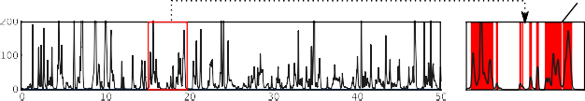Time (s)

Odor intensity (a.u.)

## C

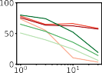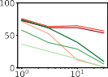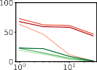Background odor compexity

Adaptive

whiff



 

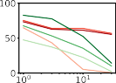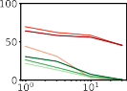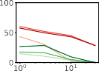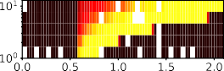Time (s)

Fluctuating odor complexity

Whiffs decoded (%)

Non-adaptive



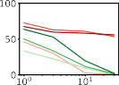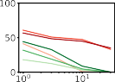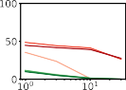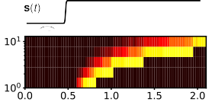Time (s)

Background odor intensity (a.u.)

Figure 4: Universal ORN adaptation operating at measured timescales aids the identification of individual odor whiffs in naturalistic odor environments. **A** Odor decoding accuracy before and after the onset of a step stimulus. Each plot shows the decoding accuracy in time for increasing adaptation time *τA*; the plots are arranged in order of increasing step stimulus strength. **B** Naturalistic odor signal measured with photo-ionization detector downwind of a source of apple cider vinegar. Whiffs are defined as contiguous regions in which the intensity is above 10 a.u. **C** Individual plots: whiff decoding accuracy as a function of background odor intensity; *τA* = 250 ms in red and non-adaptive in green, light to dark for increasing *τ*F. Rows: increasing complexity of the fluctuating odor; columns: increasing complexity of background odor.

cases, the accuracy drops to zero after the forgetting time *τ*F (here set to 4*τA*).

whiffs duration whiffs were not detected or not?

We next considered a naturalistic plume, using a recorded time trace from a photo-ionization detector placed downwind of an odor source (Fig. 4b). The sig- nal magnitude was scaled linearly to values applicable to our model framework (a.u.), and we verified that the plume statistics agree with theoretical predictions TODO. This signal serves as the intensity of the odor, to which we randomly assign a sparse identity from the *N* -dimensional odor space. To investigate dis- crimination on potentially confounding backgrounds, we add to this signal a static background odor of vary- ing intensities and complexities, and calculate the percentage of correctly decoded odor whiffs. With- out ORN adaptation, sufficiently strong backgrounds eliminate whiff-detection ability, irrespective of the complexity of either the foreground or background odor (Fig. 4c, green lines). In the adaptive system, this is substantially mitigated, (red lines in Fig. 4c)

although accuracy does decrease in general with in- creasing background complexity. Further, accurate whiff detection requires *τ*F only on the order of *τA* (darker red lines). Together, this indicates that ORN adaptation acting at measured timescales aids the de- tection of fluctuating odor signals amidst confound- ing backgrounds.

## e Relationship to primacy coding

**hypothesis**

An intriguing hypothesis emerging from recent ex- periments in vertebrates, “primacy coding,” posits that odor identity is encoded entirely by the set (but not temporal order) of the *p* earliest respond- ing glomeruli, known as “primacy sets” of order *p* (Fig. 5a). Such primacy sets would in principle com- prise a concentration-invariant representation of odor identity. In our framework, odors are decoded via in- formation passed simultaneously from all 50 ORNs. However, some of this information may be redundant, whereby a set of earliest active ORNs are sufficient

8

**A** Odor identity



Time

R50

R2 R1

ORN firing rate (Hz)

odor intensity

Number of active ORNS

ORNs

coding identity

...

Decoding accuracy

# B

Accuracy 10%

50%

100%

100%

100%



Inferred odor identity Active ORN response repertoire



Increasing odor complexity *k*

Avg. decoding accuracy (%)

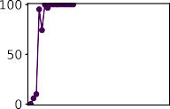

*k* = 1



*k* = 3

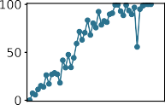

*k* = 5

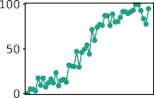

*k* = 7

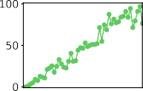

*k* = 9

Number of active ORNs (firing rate > 15 Hz)

# C D

Odor intensity

# active ORNs



Odor complexity *k*

required for >75% accuracy

Time

*k* = 1

*k* = 3

*k* = 5

*k* = 7

*k* = 9

Decoding accuracy

(ms)

Odor step intensity (a.u.)

Time Odor intensity

(a.u.)

Figure 5: **A** Primacy coding posits that only the first *p* (*p < N* ) active glomeruli are responsible for encoding odor identity. **B** Decoding accuracy as a function of the number of active ORNs (firing rate *>* 15 Hz), for different odor complexities. **C** Number of active ORNs required to fully decode odor signals of varying odor intensity and complexity. **D** Shift in time to achieve accurate odor identification, as a function of the intensity of odor steps, for various odor complexities (various green-blue lines).

for odor recognition; if so, our theory would generate predictions in agreement with primacy coding. To test this, we consider a steep sigmoidal stimulus with half-max slope of 1*/*50 ms*−*1, as in Fig. 5a. We calcu- late the decoding accuracy as a function of time, and plot in Fig. 5b the accuracy as a function of number of active ORNs, which increases monotonically as the

signal rises (Fig. 5a). To illustrate how the recruit- ment of ORNs incrementally improves odor signal recognition, we allow for partial accuracy by calcu- lating the percentage of correctly decoded individual odor components.

For sufficiently simple odors, our results are indeed in accordance with primacy coding: the set of earliest

responding neurons fully account for the odor iden- tity (*K* = 1*,* 3*,* 5 plots in Fig. 5b). Though all ORNs eventually activate as the stimulus increases, the lat- ter responders confer no further information in odor recognition. As expected, the active ORN subset comprising the primacy set is distinct for each odor, Show that recruited ORNs are all distinct. We do find, however, that for more complex odor mixtures, the full ORN repertoire must be active for accurate decoding (*K* = 7*,* 9 plots in Fig. 5b), a result that holds across odor odor concentrations (Fig. 5c). In this regime, there can be no primacy code, since a pri- macy set consisting of the full ORN repertoire would encode only a single odor. Conversely, our framework

the mushroom body [37, 19]. This inhibition obeys a type of divisive gain control, normalizing each input by the sum of ORN activity [20]. To what extent does Weber Law adaptation in the olfactory periphery act in tandem with (or counteract) this downstream nor- malization to maintain odor representations? To in- vestigate this, we extended our ORN encoding model by adding uniglomerular connections from ORNs to the antennal lobe, followed by sparse, divergent con- nections to 2500 Kenyon cells (KCs) in the mushroom body [38, 39, 40] (Fig. 6a). Divisive normalization in the AL was modeled via [20]:

*ra*(*t*)1*.*5

can decode the odor for a maximal primacy set since

it utilizes not just the identity of the active ORNs,

*r*PN*,a*

(*t*) =

*σ*1*.*5 + *r* (*t*)1*.*5 + (*γ* ),*M r* (*t*))1*.*5

(6)

it utilizes not just the identity of the active ORNs,

but also their individual firing responses. Primacy coding also predicts that for stronger stimuli, behav- ioral responses shift earlier in time, since the primacy set is activated quicker. We calculate this time shift and find that it rises monotonically with odor inten- sity over a decade of concentrations.

*a*

*b*

*b*

Primacy sets are inherently concentration- invariant. But to what extent are they conserved among varying environmental conditions, such as persistent background odors? ORNs that have adapted their gain in response to a background odor could in principle be pushed out of the primacy sets of a novel odor due to reduced sensitivity. To test this, we calculated the primacy sets for 1000 sparse odor mixtures atop a static background of a low and high intensity, comparing their primacy sets for each mixture. Primacy sets of sufficient size (*p* � 8) are almost entirely preserved across odor concentration, indicating that primacy coding, if true, would benefit from universal ORN adaptation in maintaining concentration-invariant odor repre- sentations in confounding environments. (Figure forthcoming)

Together, these results suggest that front-end adaptation, in concert with the compressed sensing paradigm, are largely in agreement with the predic- tions of the primacy coding hypotheses. Our frame- work also provides the testable prediction that pri- macy coding may break down for more complex odor mixtures.

## f Cooperative effects of ORN adaptation and downstream normalization

Lateral inhibition among antennal lobe glomeruli nor- malizes ORN responses prior to their projections to

We then quantified decoding accuracy by training and testing a binary linear classifier on the KC activ- ity output of many sparse odors of distinct intensity and identity, each randomly categorized as appeti- tive or aversive. Odor signals of the same identity but differing intensity were assigned the same valence (Fig. 6a). We trained the classifier on *p* sparse odor identities at intensities chosen randomly over 4 orders of magnitude, then tested the classifier accuracy on the same odor identities but of differing concentra- tions.

Classification accuracy degrades to chance level as the number of distinct odor identities *N*I*D* becomes very high (Fig. 6). When acting alone, either divisive normalization or ORN adaptation can mitigate this, although the effect of ORN adaptation is stronger (Fig. 6b). When both are active, accuracy improves further, suggesting that these distinct adaptive trans- formations may act jointly at different stages of neu- ral processing to preserve representations of odor identity. If odors are instead chosen from a nar- rower intensity range, performance improves without either adaptive mechanism at play (Fig. 6c). Inter- estingly, if we train the classifier to distinguish odors by their distinct identity using multiclass categoriza- tion (Fig. 6a), we find that the benefits conferred by divisive normalization do not appear until *p* is substantial, with accuracy below 65% for *N*I*D >* 50 (Fig. 6d). On the other hand, with ORN adapta- tion accuracy remains above 85% for *N*I*D* as high as 1000. Together, this indicates that front-end adapta- tion plays a key role in maintaining odor identity rep- resentations, before they are further normalized and diverged in downstream processing. In some catego- rization tasks, subsequent normalization can further preserve these representations.

Sparse connections to Kenyon cells in MB

ORNs with Divisive

Weber Law normalization

adaptation in AL

odor ID

...

odor intensity

**A**

|  |
| --- |
|  |
|  |
|  |
|  |
|  |
|  |
|  |
|  |
|  |
|  |
|  |
|  |

binary classification by odor valence

multiclass classification by odor ID

...

# B C D

binary classification with large odor intensity range

binary classification with narrow odor intensity

multi-class classification with large odor intensity range

divisive normalization

Classification accuracy

Classification accuracy

Classification accuracy

+ ORN adaptation ORN adaptation

no adaptation or normalization

divisive normalization

Number of odor signals Number of odor signals Number of odor signals

Figure 6: **A** Odors of various identity and intensity are encoded by the ORN sensing repertoire (with Weber Law adaptation), which sends signals to glomeruli in the AL, where they are further normalized via lateral inhibition. AL projections neurons then send divergent connections to Kenyon cells in the MB. A linear classifier trains the output of the MB, classifying them either by valence or by odor identity. **B** Accuracy of binary classification by odor valence, as a function of the number of distinct odor identities classified by the trained network (concentrations span 4 orders of magnitude), in systems with only ORN adaptation, only divisive normalization, both or neither. **C** Same as (B), but with concentrations spanning only 1 order. **D**, same as (B) but now classifying in distinct classes by their identity.

# Discussion

– also don’t forget to mention that the odor-receptor interactions are nonlinear and that saturation is im- portant in this case – also many odors

We investigate, through theory and computations, the implications of recent experimental evidence for a universal mechanism of input gain control in *Drosophila* olfactory receptor neurons. We argue that this mechanism, Weber’s Law of psychophysics, plays a key role in preserving neural representations of odor identity at the front-end of the olfactory pathway, prior to further transformations downstream. Tnput gain control also acts jointly with normalization in the antennal lobe, implicating the importance of sig- nal transformations at multiple steps in the circuit.

We support our conclusions using both a decoding scheme that fully reconstructs odor signals from neu- ral response, and a classification scheme that catego- rizes odors by identity or valence. We find that input gain control is especially central to the discrimination of fluctuating odor signals from potentially saturat- ing odor backgrounds. For single odorants or simple odor mixtures, our results are also consistent with the primacy coding hypothesis, that signals may be fully encoded by the primacy set of earliest activating glomeruli.

## Universal front-end adaptation in multi-channel sensory systems

In living systems, sensory adaptation ensures that re- sponses remain in regimes of maximum sensitivity, in-

11

creasing their effective dynamic range [41, 42, 43, 44]. Viewing sensory systems as input/output machines, the role of adaptation is therefore to maintain infor- mation capacity in dynamic environments [45]. Doing so requires matching sensory response to attributes of the environment, either by adapting to specific stim- uli or to stimuli statistics [41]. In a single-channel system such as bacterial chemotaxis, information ca- pacity is increased by matching the midpoint of the nonlinear dose-response curve, where sensitivity is highest, to mean ligand concentration [45]. This is enacted in a robust and dynamic way, through a feedback loop from the activity output of the pathway onto proteins dictating receptor sensitiv- ity [46, 47]. It is hypothesized that an analogous feed- back loop exists in olfactory receptor neurons, from Orco-mediated Or channel activity onto the free en- ergy of receptor activation [14]. This mechanism ap- pears to act identically across ORNs, and because ol- factory receptive fields are highly overlapping, raises questions about its efficacy in complex environments: adaptation to one odor could adversely affect identi- fication of a new odor if the latter excites some but not all of the same ORNs. Our results show that this universal mechanism of front-end gain control does help to preserve combinatorial representations of odor identity, despite these broad overlaps.

While Weber-Fechner gain control operates at the level of individual ORNs, lateral inhibition in anten- nal lobe glomeruli mixes signals among all ORNs [20]. We find that olfactory circuits exhibiting both of these adaptive mechanisms outperform systems con- taining one alone. Combinatorial coding, therefore, benefits both from the separate adaptation of indi- vidual single sensory neurons, as well as the normal- ization of aggregated response. It is notable that both Weber-Fechner adaptation and divisive normal- ization modulate the location of maximal sensitiv- ity rather than the scale of absolute activity – they move dose-response curves horizontally, rather than stretching them vertically. They are both mecha- nisms of input gain control rather than response gain control. Such input mechanisms are common to other models, sensory ssytems, etc... (...la).

Other mechanisms in the sensory periphery likely play a role in maintaining neural representations of odor identity. ORNs that contain both excitatory and inhibitory responses to odorants can increase information capacity by exploiting bidirectionality of response [48]. Antagonism among odorants, in which multiple odorants compete for common ORN

binding sites, could help maintain the sparsity of glomerular activation, provided that binding and ac- tivation strengths are uncorrelated [49]. This mech- anism requires odor-specific activation processes, i.e. G protein-coupled, cAMP-mediated transduction as in mammalian olfaction (Spehr, Munger 2009). We rely instead on experimental evidence for non-ORN- specific and non-odor-specific dynamic gain control acting via the universally expressed co-receptor Orco (Or83b) [14].

## Odor identification in natural odor

**environments**

Our results are relevant for understanding combina- torial odor coding in naturalistic odor environments. Dynamic gain control acting on a universal timescale of 250 ms allows the of determination of odor iden- tity from single whiffs, particularly when these whiffs are mixed among static backgrounds. The gains af- forded by rapid ORN adaptation increase with the strength and complexity of the background odor, sug- gesting the involvement of ORN adaptation in odor discrimination. Our results indicate that despite the generality in the adaptive mechanism (which also acts on a universal timescale), odor coding capacity and decoding fidelity are greatly enhanced.

*∼*

Indeed, Add discrimination papers here.

## Spatiotemporal odor coding and the primacy hypothesis

Previous studies implicate not only the combina- tion of active ORNs but also their distinct tempo- ral patterns as signatures of odor identity [50, 51, 52, 53]. ORNs modeled on observed features of these temporal patterns form distinct trajectories in low- dimensional projections, projections which cluster by odor identity, much as we have found here (Fig. 2b). Though we do explicitly utilize the temporal history of neural firing in our decoding schemes, the trans- mission of information over time is implicit in this framework. Because the strength of ORN feedback onto receptor complex activation depends on each ORN’s unique tuning curve, odor signals are natu- rally formatted into temporal patterns that are both odor- and ORN-specific. The response repertoire at a given time is shaped by response history via in- tegral feedback, and the short forgetting timescales, *τ*F *τ*A 250 ms, suggest that only information in brief temporal windows is required for accurate odor identification, consistent with previous findings [52].

*∼ ∼*

On the other hand, the classification scheme we em- ploy here (Figs. 6) could ...

Primacy coding also exploits the temporal se- quence of glomeruli activation, but in a coarser sense: while the order of ORN activation defines the primacy set, within this set the order is immaterial. We too find that information contained in a primacy subset

when receptor *Ra* is either unbound (Eq. 9) or bound (Eq. 10). The corresponding disassociation constants in terms of the binding transition rates are:

*k* *a−i*

*Kai* =

*k*

+

*ai*

of the full ORN repertoire can be sufficient for ac- curate reconstruction of simple odor mixtures. An extension we find, in support of the primacy coding

*Ka∗i*

*k∗−*

+

*k ∗*

=

*ai*

*ai*

(11)

hypothesis, is that primacy sets are also preserved even in the presence of potential confounds such as background odors.

# Methods

Following [14], we assume that in steady state, the

active firing state of an Or/Orco complex is ener- getically suppressed from the inactive state through corresponding Boltzmann factors:

This section needs to be redone

[*Ra∗* ]

[*Ra*]

*w*u+

= *e*

*a ≡*

*w*u*−*

*a*

*w*

*ia*

*−Ea* (12)

## a Odor-receptor binding model

b

[*Ra∗* -*si*] b+

[*Ra*-*si*] b

*≡ e−Eia .* (13)

We model an odor as an *N* -dimensional vector **s** = [*s*1*, ..., sN* ], where *si >* 0 are the concentrations of individual volatile molecules (odorants) compris- ing the odor. The olfactory sensory system is mod- eled as a collection of *M* distinct Or/Orco com- plexes, each of which can be bound with any one of the odorant molecules, and can be either active (firing) inactive (quiescent). We only consider com- petitive binding, so a complex is bound with one odorant at most. With *N* possible odorants, recep- tor *a* resides in one of 2*N* + 2 possible states, *{Ra*, *Ra∗* , *Ra*-*si*, *Ra∗* -*si}*, indicating receptors that are un-

*w −*

=

*ia*

These energies are related through detailed balance, which we assume. Applying detailed balance to a given 4-cycle

*Ra → Ra∗ → Ra∗* -*si → Ra*-*si → Ra* (14)

gives

*w*u+ *k∗*+ *w*b*− k−*

*a ia ia ia*

*w*u*− k∗− w*b+ *k*+ *≡* 1*,* (15)

*a ia ia ia*

which, in conjunction with Eqs. 11, 12, and 13, gives

r *∗*

*E*

= *E*

bound/inactive, unbound/active, inactive/bound to

odorant *i*, and active/bound to odorant *i*, respec- tively. We set *N* = 150 and *M* = 50 throughout.

b

*ai a,*act

+ ln

*Kai Kai*

*.* (16)

In the mean-field limit, the binding dynamics of these 2*N* +2 states are described by the master equa- tions:

Assuming the binding dynamics are fast, then the

probability that receptor *a* is bound by ligand *i* when inactive and active can be derived from Eqs. 7 and 8 as

*d*[*Ra*-*si*]

+ *−*

= *k si*[*Ra*] *− k* [*Ra*-*si*] (7)

*dt*

*ia*

*ia*

b *si/Kai ai* 1 + ),*N s /K*

(17)

*d*[*Ra∗* -*si*] = *k∗*+*s* [*R∗* ] *− k∗−*[*R∗* -*s* ]*,* (8)

*p*b*,∗* = *si/Ka∗i*

*.* (18)

*p*

=

*j*

*j*

*aj*

*j*

*j*

*aj*

*dt ia i a ia a i*

*ai* 1 + ),*N s /K∗*

when receptor *Ra* is either inactive (Eq. 7) or active (Eq. 8). Further, transitions between inactive and active states are described in the mean limit via:

*d*[*Ra*] = *w*u+[*R* ] *− w*u*−*[*R∗* ] (9)

The average activity *Aa* of complex *a* is the likeli- hood that the complex is active, unbound or unbound (equivalantly, the proportion of Or/Orco complexes in a given ORN that are active):

*dt a a a a*

*dt*

[*R∗* ] + ),*N* [*R∗* -*s* ]

*a*

*i*

*a*

[*R∗* ] +

*N* [*R∗* -*si*] + [*Ra*] +

*N* [*Ra*-*si*]

*d*[*Ra∗* -*si*] b+

= *wia* [*Ra*-*si*] *− wia* [*Ra*-*si*]*,* (10)

*dt*

b*− ∗*

*Aa* =

*i*

), ),

*a*

*i*

*a*

*.* (19)

*dt*

*a*

*i*

*a*

*i*

Using the master equations between active and inac- tive states Eq. 9 and 10, *Aa* obeys the master equa- tion

*dAa* = *w*+(1 *− A* ) + *w−A* (20)

*a a*

*dt a a*

with effective transition rates

*N*

AL to the Kenyon cells in the MB further mix and scramble these responses, we focus here on the infor- mation transfer at the sensory periphery alone. In any case, as demonstrated previously [31], we expect that these neural computations would only improve the representation of neural identity, so we expect no negative ramifications for our findings.

CS addresses the problem of determining a sparse

*w*+ =

*p*b *w*u+ + *p w*u

(21)

signal from a set of linear measurements, when the

*a ai ai a a*

*i*

and analogously for *wa−*. Setting Eq. 20 to zero gives the steady state average activity level of Or/Orco complex *a*:

number of measurements is less than the signal di- mension. Specifically, it is a solution to

**y** = **Rs***,* (22)

where **s** *∈* R*N* and **a** *∈* R*M* are vectors of signals and

/ 1 + ),*N s /K* *−*1

1 + *eEa,*act

*i*

*i*

*ai*

*Aa* =

*i*

*ai*

responses, respectively, and **R** is the measurement

*.* (1)

matrix. Since measurements are fewer than signal

1 + ),*N si/K∗*

components, then *M < N* , whereby **R** is wide rect-

angular and so Eq. 22 cannot be simply inverted to

## b ORN firing response

Receptor activity *Aa* is a measure of cation influx into ORNs elevates the ORN membrane voltage, which can then incite a sustained firing response. A faith- ful representation of this process would require a Hodgkin-Huxley-type model. These dynamics can

produce **s**. The idea of CS is to utilize the knowl- edge that **s** is sparse, i.e.g only *K* of its components, *K N* are nonzero. Both the measurements and sparsity are thus combined into a single constrained optimization routine:

*N*

*«*

be largely captured by a linear-nonlinear response,

which we adopt here.

*s*ˆ*i* = argmin

*|si|* such that **y** = **Rs** (23)

*i*

## c Generation of binding matrices *Ki∗a*

TODO

## Compressed sensing decoding of ORN

**response**

We decode ORN responses to infer odor signal identi- ties using an abstraction intended to mimic the neu- ral computations underlying odor identification in the *Drosophila* mushroom body. While we make no as- sumptions that the compressed sensing (CS) algo- rithm (or one like it) is being utilized in actuality, this framework nonetheless informs our understand- ing of how the neural representation of odor iden- tity is maintained or lost when passed through a dis- tributed ORN repertoire. In this sense, CS is some-

where *s*ˆ*i* are the optimal estimates of the signal com- ponents and the sum, which is known as the *L*1 norm of **s**, is a natural metric of sparsity.

Importantly, the *L*1 norm is a convex operation and the constraints are linear, so the optimization has a unique global minimum. To incorporate the nonlin- ear response of our encoding model into this linear framework, we assume that the responses are gener- ated through the full nonlinear steady state response, Eq. **??**, but that the measurement matrix needed for decoding uses a linear approximation of this trans- formation. Expanding Eq. **??** around *s*0 = *si* ∆*si* gives

*−*

*Aa ≈ Aa,*0 + ∆*Aa* (24)

*N*

what of an upper bound on how well a real neural computation might perform in decompressing ORN responses.

∆*Aa* =

*Ria*11*s*0 ∆*si* (25)

),*N s*0*/K∗*

*i*

(

1

1

0

*ia*

We assume that ORN firing rates are linear in the

*Aa,*0 =

),*N s /K∗*

*ia*

+ *eEa*

=

(26)

Or/Orco complex activity; for simplicity we let this

transform be the identity. Though subsequent neu-

*s*0

ral circuitry, particularly from the glomeruli in the

*Ria*11 ),

*eEa /Ki∗a*

*ia*

*,* (27)

*N s*0*/K∗*

+ *eEa* )2

ral circuitry, particularly from the glomeruli in the

*i*

*ia*

where we work in the approximation *Ki∗a « s*0 *« Kia*. We assume that the neural system has access to the linearized response, Eq. 27, but must infer the ex- cess signals ∆*si* from the excess activity ∆*Aa*. Corre- sponding to the CS framework, therefore, ∆**A** *→* **y**,

1∆**s** *→* **s**, and *R* 1 *→* **R**. We optimize the cost

*ia s*0

function in Eq. 23 using sequential least squares pro-

gramming, implemented in Python through using the

All the signal intensities are in arbitrary units, as they can be scaled to any range by a corresponding shift in the scales of *Kia* and *Ki∗a*.

## g Dynamic adaptation

Dynamic adaptation is enforced through

scientific package SciPy.

*dt*

*τa*

*a*

*a*

*dEa*(*t*) = 1 *A*

*− A*¯ *.* (**??**)

## Or/Orco energies of activation *Ea* and enforcement of Weber’s Law

Free energies are considered receptor-independent throughout, with the exception of dynamically adap- tive system in a temporal odor environment (Figs. 4 and **??**). To enforce Weber’s Law, we assume the re- ceptor activities feed back onto *Ea* through the free energies. For the static case, adaptation is perfect, whereby Or/Orco activities are pegged to perfectly adapted values *A*¯*a*. Incorporating this into Eq. **??**, and assuming *Ki∗a « s « Kia*, gives

/

The perfectly adapted activity levels *A*¯*a* are deter- mined by evaluating Eq. **??** at a given odor inten- sity, *s*0*,*L, corresponding to a minimum stimulus at which adaptation takes effect. The decoding step is assumed instantaneous, so decoded odor identity **ˆs** is determined by the current value of *Ea* (which, by virtue of Eq. **??**, is determined by ORN activity a short time prior).

For the simulations with two fluctuating odors (Figs. **??**), the traces shown correspond to the val- ues of *s*0 (in blue) and *s*0*,*b (orange), where *s*0*,*b is the baseline concentration of the background odor

*E*¯*a* = ln

( 1 *− A*¯*a* \

*N*

+ ln

*si* \

*.* (28)

components, to which the excess signals ∆*sk,*b are

added to set the individual odorant concentrations.

*A*¯*a*

*i Ki∗a*

We choose ∆*s*

*k,*b

*∼ N* (*s*

*k,*b

*/*3*, s*

*k,*b

*/*9).

Assuming that the excess signals are small, ∆*si < s*0, this gives

*Ea ≈* ln(*s*0) + *Ea,*0*,* (29)

where *Ea,*0 are receptor-dependent constants. In the static case, we choose these constants such that *Ea* in both adaptive and non-adaptive systems are equiva- lent, equal to *E*L, at a given low concentration, *s*0*,*L. Below this concentration, we assume adaptation is not in effect, so *Ea* = *E*L.

It is important to note that while the linearized gain Eq. 27 utilized by the decoding algorithm ap- pears to rely on *Ea*, by the above argument *Ea* can in principle be determined by firing rates alone. That is, *Ea* is inferred in time through integration of Eq. **??**, which relies only on the current ORN activity.

## Odor signals

Odor signals **s** are *N* -dimensional vectors presumed sparse whereby only *K* components, *sk* are nonzero, *K « N* . The magnitudes of the nonzero compo- nents *sk* are denoted *s*0 +∆*sk*. Here, ∆*sk* is a random vector, while *s*0 is both the center of linearization and, in the case of the adaptive system, the value dictating the strength of adaptive feedback *Ea ∼* ln*(s*0*)*.

## h Parameter values used in all figures

Parameter values for all of the plots are listed in Ta- ble 1.

Figure *N M K µa,*L *µa,*H *νa,*L *νa,*H *Ea,*0 *E*L *E*H *s*0*,*L *sk sk,*F

1c 200 40 6 2 *·* 10*−*4 10*−*3 10*−*2 1.0 5.4 5.4 10 - *N s*0 *, s*0 –

5.4 3.1 10 10*−*1 *N s*0 *, s*0 –

5

15

|  |  |  |  |  |  |  |
| --- | --- | --- | --- | --- | --- | --- |
| 3a 100 | 50 7 | 0.5 | 0.5 | 0.8 | 0.8 |  |
| 3b 100 | 50 7 | 0.5 | 0.6 | 0.6 | 0.9 | *−*1 *s*0 *s*0 |
| 3c 100 | 50 7 | 0.5 | 0.6 | 0.6 | 0.9 | *−*1 *s*0 *s*0 |
| **??**-**??** 100 | 50 7 | 0.5 | 0.6 | 0.6 | 0.9 | *−*1 *s*0 *s*0 1 |
| 4 100 | 50 7 | 0.5 | 0.6 | 0.6 | 0.9 | *−*2 *s*0 *s*0 |
| **??** 100 | 50 7 | 0.5 | 0.6 | 0.6 | 0.9 | *−*2 *s*0 *s*0  3 9 |

5.4 3.1 10 10

*N* 3 *,* 15 –

5.4 3.1 10 10

5.4 3.1 10 10

– – – 10

– – – 10

Table 1: Parameters for simulations in all of the figures.

*N* 3 *,* 15 —

*N* 3 *,* 15 *N* (1*,* )

*N* 3 *,* 15 – 5

*N* 3 *,* 9 –

# References

1. A. Couto, M. Alenius, and B. J. Dickson, “Molecular, anatomical, and functional organi- zation of the drosophila olfactory system,” *Cur- rent Biology*, vol. 15, no. 17, 2005.
2. L. Buck and R. Axel, “A novel multigene fam- ily may encode odorant receptors: a molecular basis for odor recognition,” *Cell*, vol. 65, no. 1, pp. 175–187, 1991.
3. B. Malnic, J. Hirono, T. Sato, and L. B. Buck, “Combinatorial receptor codes for odors,” *Cell*, vol. 96, no. 5, pp. 713–723, 1999.
4. G. Wang, A. F. Carey, J. R. Carlson, and

L. J. Zwiebel, “Molecular basis of odor coding in the malaria vector mosquito anopheles gam- biae,” *Proceedings of the National Academy of Sciences*, vol. 107, no. 9, pp. 4418–4423, 2010.

1. J. G. Hildebrand and G. M. Shepherd, “Mech- anisms of olfactory discrimination: converging evidence for common principles across phyla,” *Annual review of neuroscience*, vol. 20, no. 1, pp. 595–631, 1997.
2. E. Hallem and J. Carlson, “Coding of odors by a receptor repertoire,” *Cell*, vol. 125, no. 1, pp. 143–160, 2006.
3. M. de Bruyne, K. Foster, and J. R. Carlson, “Odor coding in the drosophila antenna,” *Neu- ron*, vol. 30, no. 2, pp. 537 – 552, 2001.
4. R. W. Friedrich and S. I. Korsching, “Combina- torial and chemotopic odorant coding in the ze- brafish olfactory bulb visualized by optical imag- ing,” *Neuron*, vol. 18, no. 5, pp. 737–752, 1997.
5. R. I. Wilson, “Early olfactory processing in *Drosophila*: mechanisms and principles,” *An- nual Review of Neuroscience*, vol. 36, no. 1, pp. 217–241, 2013.
6. J. Murlis, “Odor plumes and how insects use them,” *Annual Review of Entymology*, vol. 37, pp. 505–532, 1992.
7. M. Weissburg, “The fluid dynamical context of chemosensory behavior,” *The Biological Bul- letin*, vol. 198, no. 2, pp. 188–202, 2000. PMID: 10786940.
8. A. Celani, E. Villermaux, and M. Vergassola, “Odor landscapes in turbulent environments,” *Phys. Rev. X*, vol. 4, p. 041015, Oct 2014.
9. R. T. Card´e and M. A. Willis, “Navigational strategies used by insects to find distant, wind- borne sources of odor,” *Journal of Chemical Ecology*, vol. 34, pp. 854–866, Jul 2008.
10. S. Gorur-Shandilya, M. Demir, J. Long, D. A. Clark, and T. Emonet, “Olfactory receptor neu- rons use gain control and complementary ki- netics to encode intermittent odorant stimuli,” *eLife*, vol. 6, p. e27670, jun 2017.
11. M. Renou, V. Party, A. Rouyar, and S. An- ton, “Olfactory signal coding in an odor back- ground,” *Biosystems*, vol. 136, pp. 35 – 45, 2015.
12. G. Si, J. K. Kanwal, Y. Hu, C. J. Tabone,

J. Baron, M. E. Berck, G. Vignoud, and A. D. Samuel, “Invariances in a combinatorial olfac- tory receptor code,” *bioRxiv*, p. 208538, 2017.

1. S. A. Montague, D. Mathew, and J. R. Carl- son, “Similar odorants elicit different behav- ioral and physiological responses, some supersus- tained,” *Journal of Neuroscience*, vol. 31, no. 21, pp. 7891–7899, 2011.
2. C. Martelli, J. R. Carlson, and T. Emonet, “In- tensity invariant dynamics and odor-specific la- tencies in olfactory receptor neuron response,” *Journal of Neuroscience*, vol. 33, no. 15, pp. 6285–6297, 2013.
3. K. Asahina, M. Louis, S. Piccinotti, and

L. Vosshall, “A circuit supporting concentration- invariant odor perception in *Drosophila*,” *Jour- nal of Biology*, vol. 8, no. 1, p. 9, 2009.

1. S. R. Olsen, B. Vikas, and R. I. Wilson, “Divisive normalization in olfactory population codes,” *Neuron*, vol. 66, pp. 287–299, 2010.
2. M. Papadopoulou, S. Cassenaer, T. Nowotny, and G. Laurent, “Normalization for sparse en- coding of odors by a wide-field interneuron,” *Sci- ence*, vol. 332, no. 6030, pp. 721–725, 2011.
3. E. H. Weber, *EH Weber on the tactile senses*. Psychology Press, 1996.
4. J. Cafaro, “Multiple sites of adaptation lead to contrast encoding in the *Drosophila* olfactory system,” *Physiological Reports*, vol. 4, no. 4, p. e12762, 2016.
5. L.-H. Cao, B.-Y. Jing, D. Yang, X. Zeng,

Y. Shen, Y. Tu, and D.-G. Luo, “Distinct sig- naling of *Drosophila* chemoreceptors in olfactory sensory neurons,” *Proceedings of the National Academy of Sciences*, vol. 113, no. 7, pp. E902– E911, 2016.

1. H. Guo and D. P. Smith, “Odorant receptor de- sensitization in insects,” *Journal of Experimen- tal Neuroscience*, vol. 11, pp. 1–5, 2017.
2. H. Guo, K. Kunwar, and D. Smith, “Odorant receptor sensitivity modulation in *Drosophila*,” *The Journal of Neuroscience*, vol. 37, no. 39, pp. 9465–9473, 2017.
3. C. D. Wilson, G. O. Serrano, A. A. Koulakov, and D. Rinberg, “A primacy code for odor iden- tity,” *Nature Communications*, vol. 8, no. 1, p. 1477, 2017.
4. H. Giaffar, D. Rinberg, and A. A. Koulakov, “Primacy model and the evolution of the olfac- tory receptor repertoire,” *biorxiv*, 2018.
5. L. van der Maaten and G. Hinton, “Visualizing high-dimensional data using t-sne,” *Journal of Machine Learning Research*, vol. 9, pp. 2579– 2605, 2008.
6. L. B. Vosshall, A. M. Wong, and R. Axel, “An olfactory sensory map in the fly brain,” *Cell*, vol. 102, no. 2, pp. 147 – 159, 2000.
7. K. Krishnamurthy, A. M. Hermundstad,

T. Mora, A. M. Walczak, and V. Balasubrama- nian, “Disorder and the neural representation of complex odors: smelling in the real world,” *bioRxiv*, vol. doi:10.1101/160382, 2017.

1. D. Donoho, “Compressed sensing,” *IEEE Trans- actions on Information Theory*, vol. 52, no. 4, pp. 1289–1306, 2006.
2. E. Candes, J. Romberg, and T. Tao, “Robust uncertainy principles: Exact signal reconstruc- tion from highly incomplete frequency informa- tion,” *IEEE Transactions on Information The- ory*, vol. 52, no. 2, pp. 489–509, 2006.
3. S. Ganguli and H. Sompolinsky, “Compressed sensing, sparsity, and dimensionality in neuronal information processing and data analysis,” *An- nual Review of Neuroscience*, vol. 35, no. 1, pp. 485–508, 2012.
4. C. Pehlevan, A. Genkin, and D. B. Chklovskii, “A clustering neural network model of insect ol- faction,” in *2017 51st Asilomar Conference on Signals, Systems, and Computers*, pp. 593–600, 2017.
5. G. Lan, P. Sartori, S. Neumann, V. Sourjik, and Y. Tu, “The energy-speed-accuracy tradeoff in sensory adaptation,” *Nature physics*, vol. 8, no. 5, pp. 422–428, 2012.
6. S. R. Olsen and R. I. Wilson, “Lateral presy- naptic inhibition mediates gain control in an ol- factory circuit,” *Nature*, vol. 452, pp. 952–960, 2008.
7. A. C. Keene and S. Waddell, “*Drosophila* olfac- tory memory: single genes to complex neural circuits,” *Nature Reviews Neuroscience*, vol. 8, pp. 341–354, 2007.
8. A. Litwin-Kumar, K. D. Harris, R. Axel,

H. Sompolinsky, and L. Abbott, “Optimal de- grees of synaptic connectivity,” *Neuron*, vol. 93, no. 5, pp. 1153 – 1164.e7, 2017.

1. S. Caron, V. Ruta, L. Abbott, and R. Axel, “Random convergence of olfactory inputs in the *Drosophila* mushroom body,” *Nature*, vol. 497, no. 4774, pp. 113–117, 2013.
2. B. Wark, B. N. Lundstrom, and A. Fairhall, “Sensory adaptation,” *Current Opinion in Neu- robiology*, vol. 17, no. 4, pp. 423–429, 2007.
3. K. I. Nagel and A. J. Doupe, “Temporal pro- cessing and adaptation in the songbird auditory forebrain,” *Neuron*, vol. 51, no. 6, pp. 845 – 859, 2006.
4. S. B. Laughlin, “A simple coding procedure enhances a neuron’s information capacity,” *Zeitschrift fu¨r Naturforschung C*, vol. 36, no. 9- 10, pp. 910–912, 1981.
5. M. DeWeese and A. Zador, “Asymmetric dy- namics in optimal variance adaptation,” *Neural Computation*, vol. 10, pp. 1179–1202, 1998.
6. I. Nemenman, “Information theory and adap- tation,” in *Quantitative Biology: From Molec- ular to Cellular Systems* (M. E. Wall, ed.), ch. 4, pp. 73–91, USA: CRC Press, 2012.
7. N. Barkai and S. Leibler, “Robustness in sim- ple biochemical networks,” *Nature*, vol. 387, pp. 913–917, 1997.
8. U. Alon, M. Surette, B. N., and S. Leibler, “Robustness in bacterial chemotaxis,” *Nature*, vol. 397, pp. 168–171, 1999.
9. L.-H. Cao, D. Yang, W. Wu, X. Zeng, B.-Y. Jing, M.-T. Li, S. Qin, C. Tang, Y. Tu, and D.-G. Luo, “Odor-evoked inhibition of olfac- tory sensory neurons drives olfactory perception in *Drosophila*,” *Nature Communications*, vol. 8, no. 1, p. 1357, 2017.
10. G. Reddy, J. Zak, M. Vergassola, and V. N. Murthy, “Antagonism in olfactory receptor neu- rons and its implications for the perception of odor mixtures,” *bioRxiv*, p. 204354, 2017.
11. B. Raman, J. Joseph, J. Tang, and M. Stopfer, “Temporally diverse firing patterns in olfactory receptor neurons underlie spatiotemporal neu- ral codes for odors,” *Journal of Neuroscience*, vol. 30, no. 6, pp. 1994–2006, 2010.
12. N. Gupta and M. Stopfer, “Insect olfactory cod- ing and memory at multiple timescales,” *Current Opinion in Neurobiology*, vol. 21, pp. 768–773, 2011.
13. S. L. Brown, J. Joseph, and M. Stopfer, “Encod- ing a temporally structured stimulus with a tem- porally structured neural representation,” *Na- ture Neuroscience*, vol. 8, pp. 1568–1576, 2005.
14. N. Gupta and M. Stopfer, “A temporal channel for information in sparse sensory coding,” *Neu- ron*, pp. 2247–2256, 2014.